# QuestLabs Final Report

*A personal development companion app helping college students build reflection habits, track long-term goals, and grow together in supportive cohorts*

**Team Members:**

Zhi Kang (Student ID: 300416721)

Dong Zhang (Student ID: 300403848)

Course: CSIS 3375 - Section 1

Douglas College

**Team Lead:** Zhi Kang

**Instructor:** Padmapriya Arasanipalai Kandhadai

November 27 2025

## 1.Title Page

### 1.1 App Name

QuestLabs



### 1.2 App Description

A holistic growth companion for college students, integrating emotional wellness, relationship tracking, and goal progress within structured peer communities.

### 1.3 Team Members

Team leader: Zhi Kang

Student ID: 300403869

E-mail: kangz4@student.douglascollege.ca

Team member: Dong Zhang

Student ID: 300403848

E-mail: windyheratz5201314@gmail.com

Course section: CSIS 3375 001

Overall Percentage Contributions: (关键！)

## **2.**App Idea & Background

### **2.1**App Description

QuestLabs Companion integrates emotional wellness, relational quality, and academic progress tracking for college students in cohort-based programs. The app provides daily reflection prompts (under 2 minutes), three-layer goal frameworks (vision → quarterly → weekly), and peer accountability within small groups of 5-10 students.

### 2.2 Novelty

Unlike single-purpose apps (Daylio for mood, Todoist for tasks), QuestLabs Companion treats life dimensions as interconnected. It serves known small groups rather than anonymous communities, emphasizing collaborative growth over competition through an intentionally anti-gamified design.

### 2.3 Transformative Experience

Students shift from reactive to intentional living through structured reflection, developing metacognition about their own patterns. The cohort structure provides accountability without judgment, while the three-layer framework connects daily actions to future aspirations.

### 2.4 Competitor Analysis

1. **Daylio:** Mood tracker with quick icon-based logging and statistical analysis. Strong individual tracking but no community features or goal integration.

2. **Habitica:** Gamified habit tracker with party/guild features. Effective motivation but competitive design contradicts collaborative growth philosophy.

3. **Reflectly:** AI-powered journal with adaptive prompts. Entirely individual focus, requires 5-10 minutes daily, premium features cost $60/year.

4. **Strides:** Flexible goal/habit tracker with strong data visualization. No emotional context or social features.

5. **Notion:** Customizable workspace for notes and tasks. Powerful but overwhelming for users seeking structured guidance.

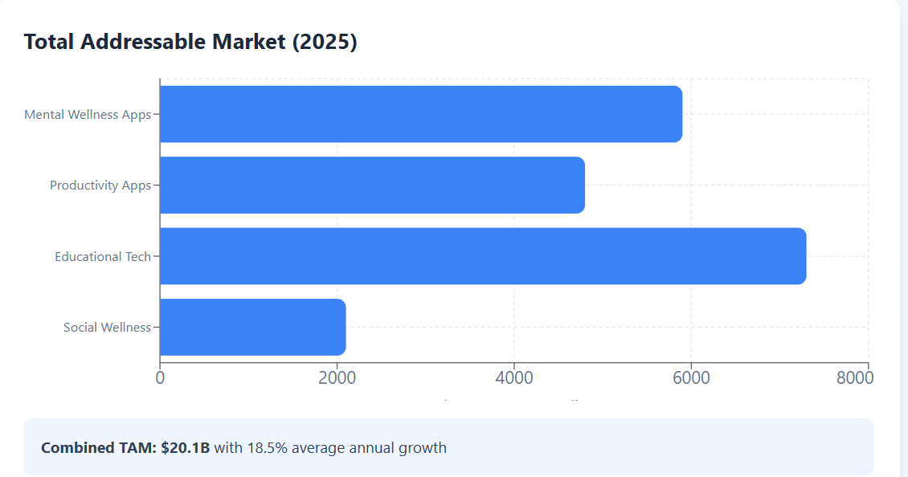

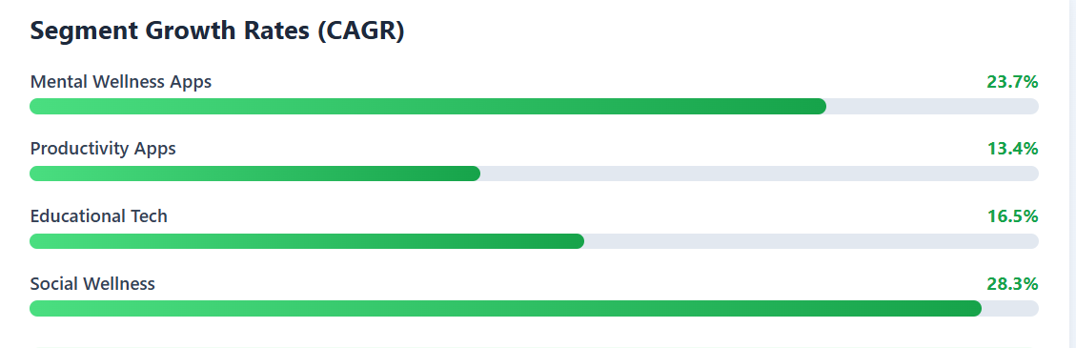

**Highest Growth: Social Wellness (28.3%) and Mental Wellness (23.7%) - QuestLabs' core focus areas**

No existing app integrates emotional wellness, relational quality, and academic progress within small-group accountability frameworks.

*Source:* <https://www.grandviewresearch.com/industry-analysis/mental-health-apps-market-report>

<https://www.fortunebusinessinsights.com/mental-health-apps-market-109012>

https://www.businessresearchinsights.com/market-reports/productivity-apps-market-117791

<https://media.market.us/mental-health-apps-market-news-2024/>

https://upbase.io/blog/18-best-productivity-apps-for-students/

### 2.5 Market Inspiration

1. **Strava:** Privacy-preserving social visibility—users see peers' activity without detailed data. Applied to QuestLabs through aggregated cohort progress displays.

2. **Forest:** Visualizes abstract progress (focus time) as tangible growth (trees). Applied through journey metaphors for personal development.

3. **Discord:** Channel-based community organization. Applied through cohort-specific structured spaces.

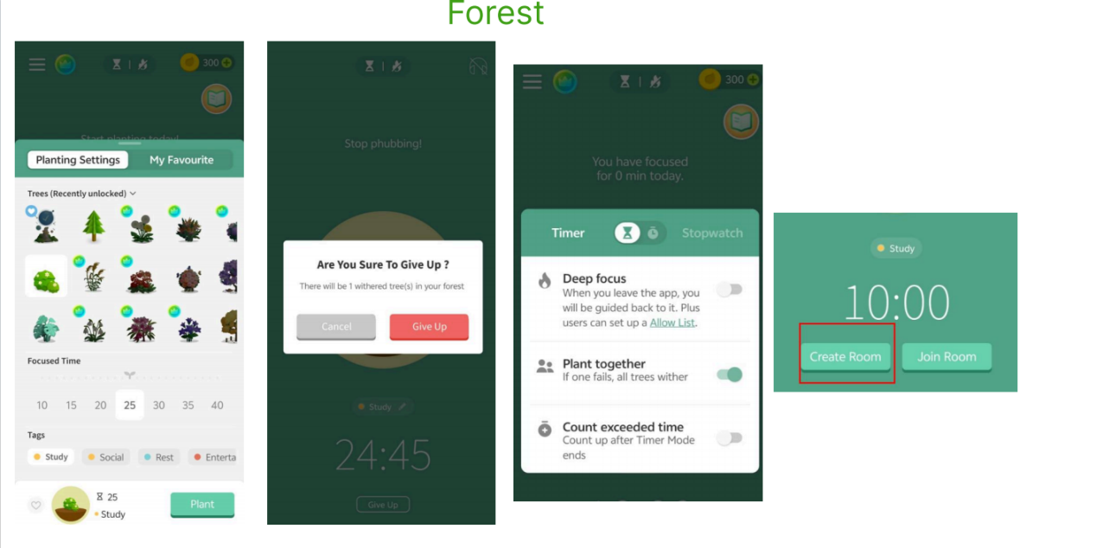

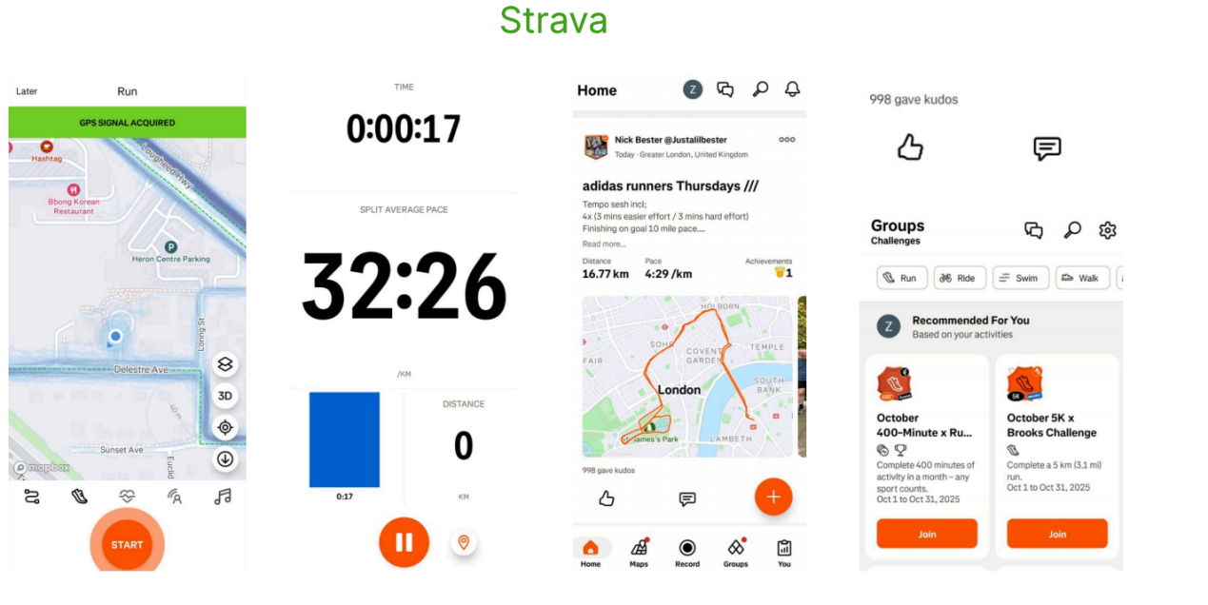

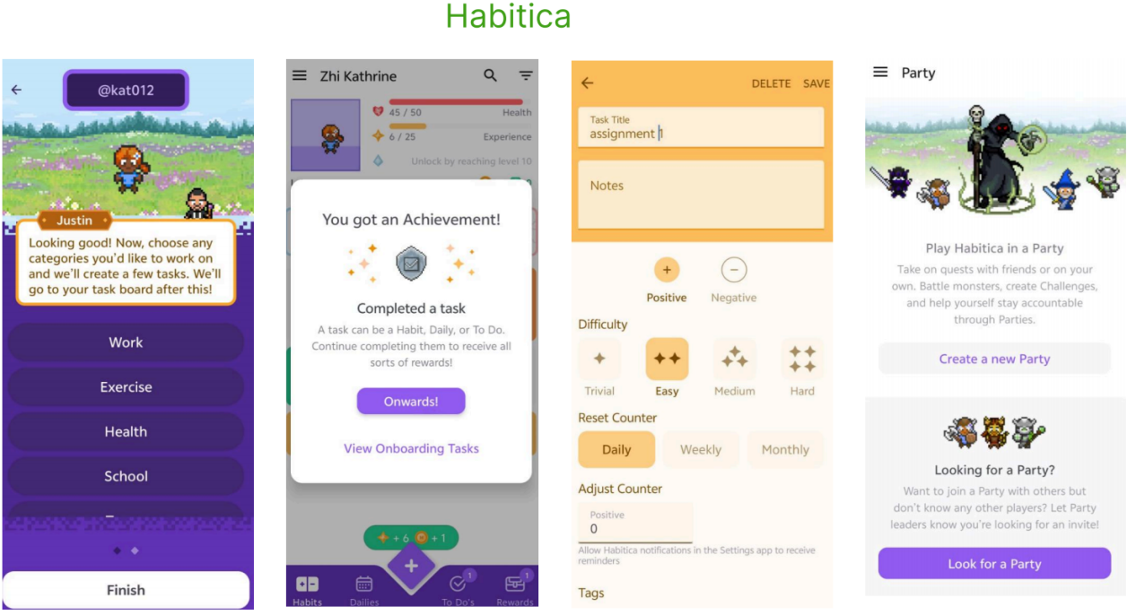

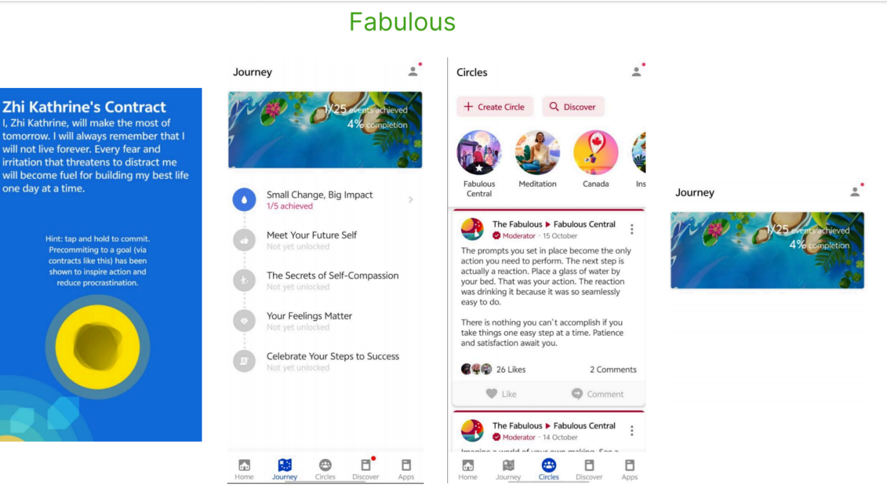

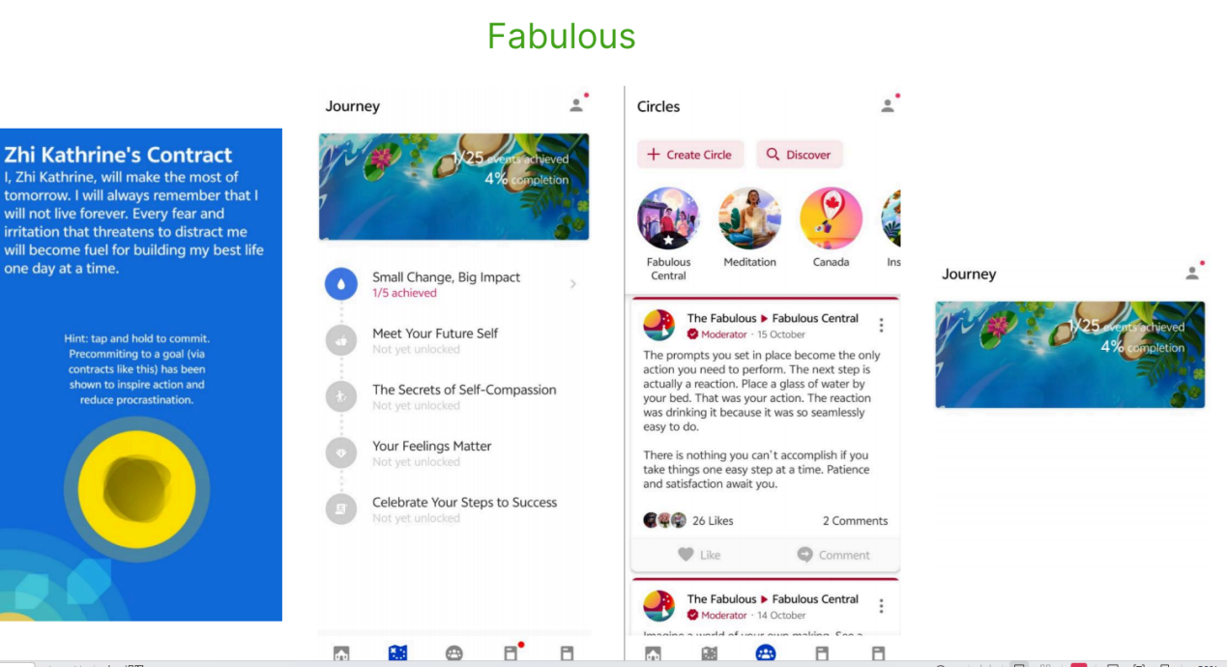

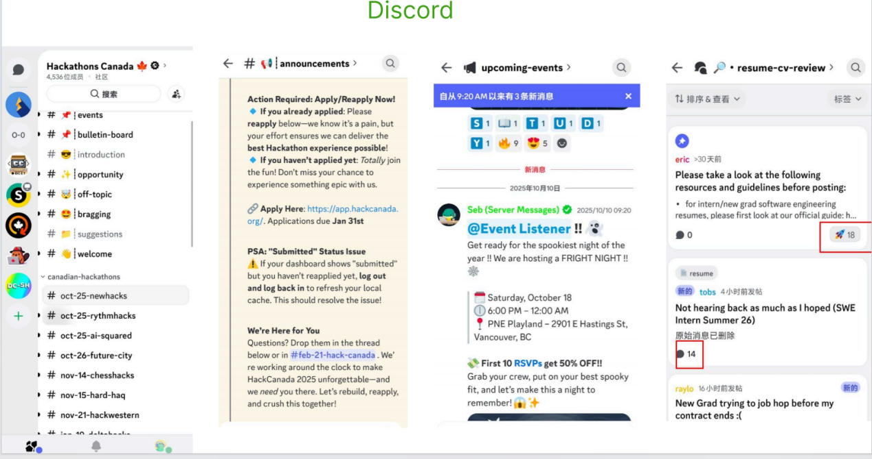

**2.6 Insight**

So for the QuestLabs, we can focus on the specific features and do our designs:

#### Holistic Integration

Only app combining emotional wellness, relational quality, and academic progress in one platform

#### Small Group Accountability

Privacy-preserving cohort system inspired by Strava's social model - see progress without exposed data

#### Quick + Structured

Under 2 minutes daily with guided prompts - combines Daylio's speed with Reflectly's guidance

Simplicity (<2 min daily), structured guidance, and privacy-aware community features drive sustained engagement.

### 2.6 PACT Framework

#### People

**Primary:** College students (18-30) in structured development programs. Digitally fluent but time-constrained, seeking meaningful engagement over passive consumption. Value peer connection within small trusted groups.

**Secondary:** Program facilitators needing aggregated cohort insights without individual privacy invasion.

#### Activities

**Goal Management (Time-spanning):**

1. Future visioning (one-time, 15-20 min): Articulate 3-year aspirations

2. Quarterly goal setting (every 3 months, 10-15 min): Align with vision

3. Weekly planning (weekly, 5-10 min): Set specific actions

4. Daily progress tracking (daily, <1 min): Note which goals worked on

**Reflection & Awareness:**

1. Daily emotional check-in (daily, 1-2 min): Rate three dimensions

2. Reflection entries (2-3x/week, 2-5 min): Process experiences

3. Monthly progress review (monthly, 5-10 min): Visualize trends Community

4. Cohort engagement (2-3x/week, 3-5 min): View peer progress, encourage

#### Context

- Physical: Dorm rooms, libraries, commute; smartphone primary device

- Temporal: Morning (7-9am) or evening (9-11pm); must fit <5 min windows

- Social: Small cohorts (5-10) with face-to-face meetings; privacy essential

- Emotional: Users often stressed, seeking grounding not judgment

- Technical: Reliable connectivity assumed; lightweight design required

#### Technologies

**Required:**

- Cross-platform mobile framework (React Native/Flutter)

- Cloud database & authentication (Firebase/Supabase)

- Data visualization (Recharts/Victory)

- Push notifications (FCM/OneSignal)

- Offline storage (AsyncStorage)

**Key Insights:**

Time-constrained users in interruptible contexts require activities under 2 minutes with mobile-optimized, privacy-preserving community features and structured guidance over flexibility.

#### Value Proposition

For college students in structured personal development programs who need to sustain reflection and goal progress beyond program duration,

QuestLabs Companion is a mobile tracking tool that integrates emotional wellness, relational quality, and academic goals while connecting daily actions to long-term aspirations within small peer cohorts.

Unlike standalone mood trackers, gamified habit apps, or overwhelming flexible tools, our app provides structured three-dimensional tracking designed for small known groups, emphasizing collaborative growth over individual competition.

## **3.**User Study 1 (Requirements Gathering)

### 3.1 Purpose and Objectives

We conducted this user study to understand the needs and challenges of college or university students interested in personal development. Our main objectives were:

* To identify current reflection habits and frequency among college students
* To discover barriers preventing consistent personal development practices
* To validate our assumption about quick daily check-ins (under 2 minutes)
* To determine preferences for visual vs. text-based progress tracking
* To assess the importance of peer accountability features
* To identify most desired app features
* To understand users' willingness for long-term goal planning
* To discover privacy concerns in cohort settings

### 3.2 User Study Choice and Sample

**Method:** We used an online survey because it efficiently reaches many students and provides data for statistical analysis. The survey included both closed-ended (multiple choice) and open-ended questions to capture measurable preferences and detailed insights.

**Target Users:** College students (undergraduate and graduate) aged 18-31+ interested in personal development, who balance academics with other responsibilities and struggle with consistent reflection.

**Sample:** 14 valid responses collected over 7 days (October 16-23, 2025). 50% graduate students, 43% undergraduates, 65% aged 27+.

### 3.3 Survey Questions

Below is the complete survey we used for our requirements gathering. The survey was distributed through Google Forms and included 17 questions organized into five main sections.

**Link:**<https://docs.google.com/forms/d/e/1FAIpQLSecelozNUqU-wZzHfmVYWwrKLkcN-iYRBxQTutOt5N7o5qchw/viewform>

**Target Time:** 4-5 minutes per response  
**Purpose:** Explore college students' current habits, preferences, and pain points related to personal reflection, goal tracking, and peer accountability.

#### Section 1: Screening and Demographics

**Q1. [Required] Are you currently a college/university student?**

* Yes, full-time undergraduate
* Yes, part-time undergraduate
* Yes, graduate student
* No, but I graduated within the last 2 years
* No → [Survey ends]

**Q2. [Required] Age range:**

* 18-20
* 21-23
* 24-26
* 27-30
* 31+

**Q3. Have you ever participated in a personal development program, workshop, or cohort?**

* Yes, in a structured program (like Quest Labs, coaching cohort, etc.)
* Yes, informally (online community, study group, etc.)
* No, but I'm interested
* No, and I'm not interested

#### Section 2: Current Habits and Pain Points

**Q4. How often do you intentionally reflect on your emotions, relationships, or goals?**

* Daily
* 2-3 times per week
* Weekly
* Monthly or less
* Rarely or never

**Q5. What's the BIGGEST challenge that prevents you from maintaining regular reflection habits? [Select up to 2]**

* I don't have time
* I don't know what to reflect on
* It feels overwhelming or boring
* I forget to do it
* I don't see the value/results
* I prefer talking to someone instead of writing
* Other: [text field]

**Q6. Do you currently use any apps or tools to track your mood, goals, or habits?**

* Yes, regularly [If yes → "Which ones?" (optional text field)]
* Yes, but I stopped using them
* No, I use pen and paper
* No, I don't track anything

**Q7. [Conditional - only shown if Q6 = "stopped"] If you stopped using a tracking app, what was the main reason?**

* Too time-consuming
* Too complicated
* Felt like a chore, not helpful
* Didn't integrate different life areas
* Privacy concerns
* Other: [text field]

#### Section 3: Preferences and Design Insights

**Q8. How much time would you realistically spend on a daily check-in app?**

* Under 1 minute (just a few taps)
* 1-2 minutes (quick ratings + optional note)
* 3-5 minutes (some writing/reflection)
* 5-10 minutes (detailed journaling)
* 10+ minutes

**Q9. Which format do you prefer for tracking progress over time?**

* Visual graphs and charts
* Written journal entries
* Calendar/streak view
* A mix of visuals and text
* I don't care about tracking history

**Q10. Rate your interest in these features: [Scale: 1 = Not interested at all → 5 = Very interested]**

* Quick daily mood check-in (1-2 min)
* Long-term goal tracking (3 months+)
* Structured reflection prompts (fill-in-the-blank)
* Progress dashboard with trend graphs
* See your peer group's aggregated progress (anonymous)
* Give/receive encouragement reactions from peers

**Q11. Which statement best describes your ideal reflection tool?**

* "Give me complete freedom to write whatever I want" (blank canvas)
* "Give me some structure but also flexibility" (prompts + open space)
* "Give me clear structure and guidance" (templates, fill-in-blanks)
* "Just let me rate things quickly and see patterns" (minimal writing)

#### Section 4: Social and Privacy

**Q12. In a small growth group (5-10 people), what would make you comfortable sharing progress? [Select all that apply]**

* Knowing members personally
* Only seeing group summaries (no individual details)
* Controlling what I share
* No public profiles or rankings
* Anonymous usernames
* I wouldn't share at all

**Q13. How important is peer accountability to your personal growth?**

* Very important - I need others to stay motivated
* Somewhat important - it helps but isn't essential
* Not very important - I prefer working independently
* Not important at all - accountability feels like pressure

**Q14. If you were in a personal growth cohort, what support from the group would be most helpful? [Select up to 3]**

* Weekly check-ins or standups
* Celebrating milestones together
* Accountability reminders from peers
* Sharing struggles/challenges openly
* Giving/receiving encouragement reactions
* Collaborative goal-setting sessions
* Seeing others' progress for motivation
* Anonymous peer feedback
* One-on-one buddy system
* I prefer not to engage with the group
* Other: [text field]

**Q15. What would motivate you to keep using a personal development app? [Rank top 3 or select top 3]**

* Seeing my own progress over time
* Encouragement from peers
* Achieving my long-term goals
* Understanding patterns in my emotions/behavior
* Feeling part of a supportive community
* Quick and easy to use
* Beautiful, enjoyable interface
* Reminders and notifications

##### Section 5: Open Feedback

**Q16. If you could wave a magic wand and create the perfect personal development companion app, what ONE feature would it MUST have?** [Optional]

**Q17. Any other thoughts, concerns, or ideas about tracking emotional wellness, relationships, and goals in a cohort setting?** [Optional]

### 3.4 Data Analysis

**Sample Size:** 14 valid responses (50% graduate, 43% undergraduate, 65% aged 27+)

The following are some charts of the analysis results:

**Key Findings:**

* **Reflection Frequency:** Only 14% reflect daily; 43% weekly, 36% 2-3x/week → habit gap exists
* **Top Barriers:** 64% forget, 36% lack time, 29% don't know what to reflect on
* **Time Preference:** 79% want <2min check-ins (50% want <1min) → strongest validation
* **Format Preference:** 71% prefer visual tracking; 0% want text-only
* **Top Features (4-5 rating):** Long-term goals 79%, Dashboard 64%, Reactions 64%
* **Privacy:** 71% need sharing control, 43% reject public rankings
* **Top Motivator:** 79% motivated by seeing own progress

### 3.5 Key Insights

* "Forgetting" is the #1 barrier (64%) → reminders are essential
* 79% want <2min check-ins → speed is non-negotiable
* 71% prefer visual formats → dashboard is must-have
* 79% high interest in long-term goals → should be P0 priority
* 64% value peer support BUT 71% need privacy → aggregated cohort design validated
* 36% prefer independence → solo mode must work fully
* Function > form: Only 21% motivated by beautiful interface

## **4.**Requirements Generation

### 4.1 Personas and Scenarios

https://www.figma.com/design/7yernNajsd3bIY94FhmVon/Personas-and-Scenarios?node-id=0-1&t=8Ubo8iYRTC65XMh5-1

We created 4 diverse personas representing our target users:

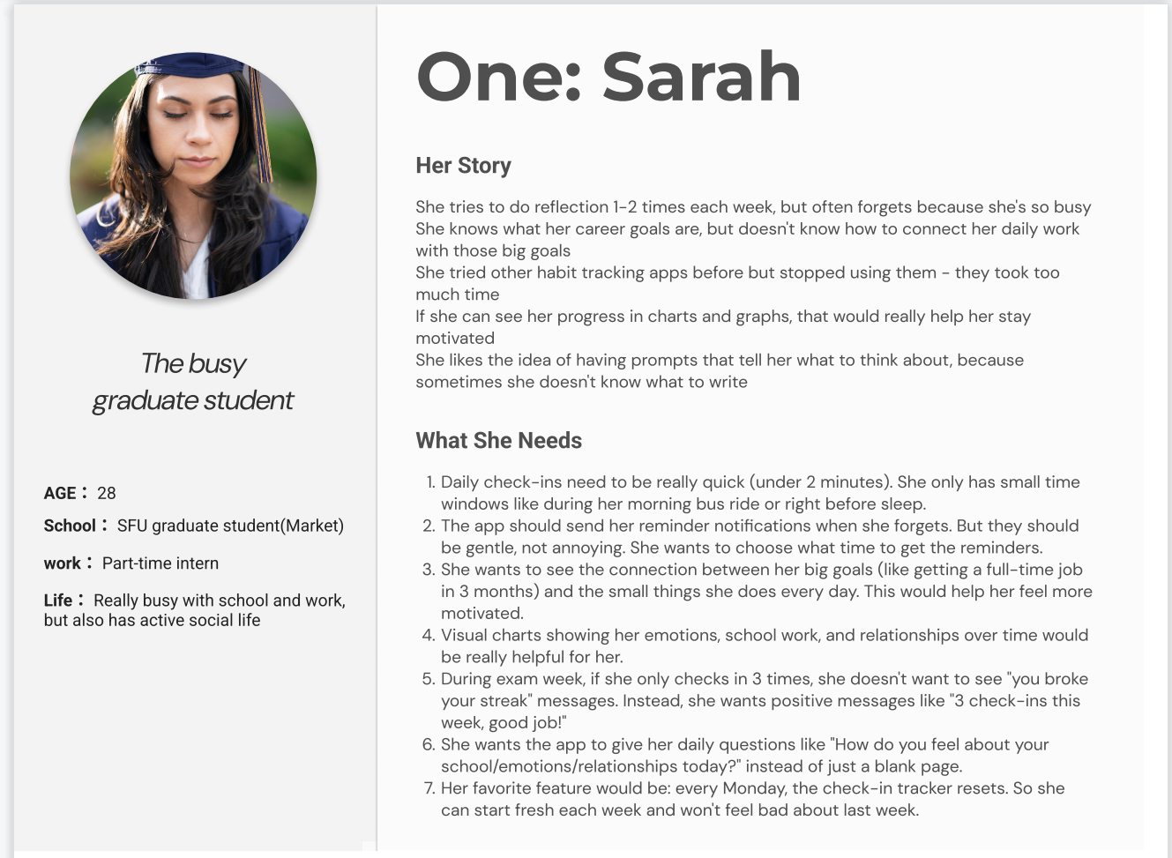

**Persona 1: Sarah - The Busy Graduate Student**

**Age:** 28 | **Role:** Part-time intern, SFU Marketing graduate student

**Life:** Very busy with school and work, active social life

**Her Story:**

Sarah tries to reflect 1-2 times weekly but often forgets because she's busy. She knows her career goals but doesn't know how to connect daily work with those goals. She tried habit apps before but stopped - they took too much time. Visual progress charts would help her stay motivated.

**What She Needs:**

* Check-ins under 2 minutes (during bus ride or before sleep)
* Gentle reminder notifications at chosen times
* See connection between daily actions and 3-month goals
* Visual charts showing emotions, school, relationships over time
* Positive messaging (not "you broke your streak")
* Daily prompts instead of blank pages
* Weekly reset - fresh start every Monday

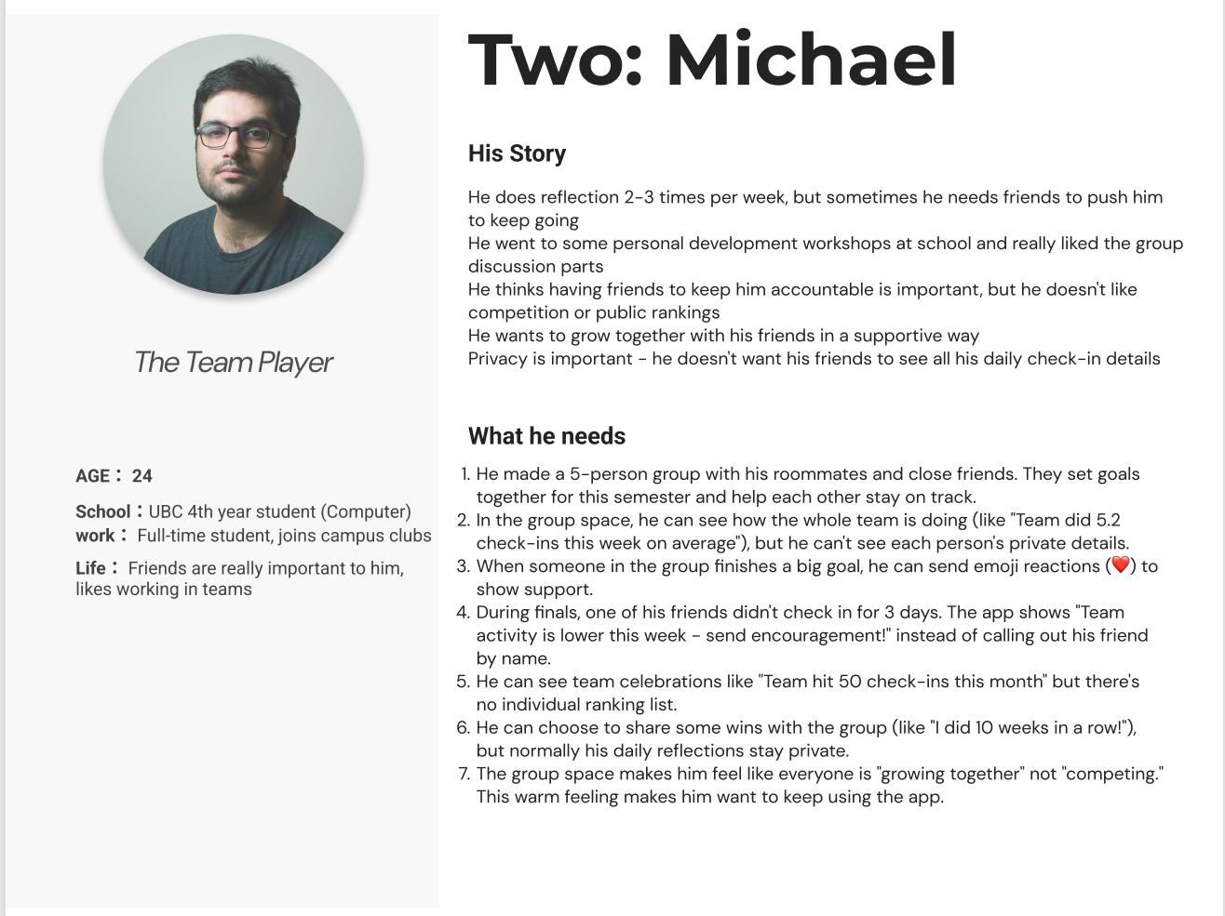

**Persona 2: Michael - The Team Player**

**Age:** 24 | **Role:** UBC 4th year Computer Science, joins campus clubs

**Life:** Friends important, likes working in teams

**His Story:**

Michael reflects 2-3x/week but needs friends to stay accountable. He likes group discussions but doesn't want competition or public rankings. He values growing together with friends in supportive ways. Privacy is important - doesn't want friends seeing all details.

**What He Needs:**

* Small cohorts (5-10 people) with close friends
* See aggregated team progress, not individual scores
* Send emoji reactions to celebrate wins
* Protected privacy - teammates can't see personal details
* Team celebrations without individual rankings
* Optional sharing - daily reflections stay private
* "Growing together" feeling, not competing

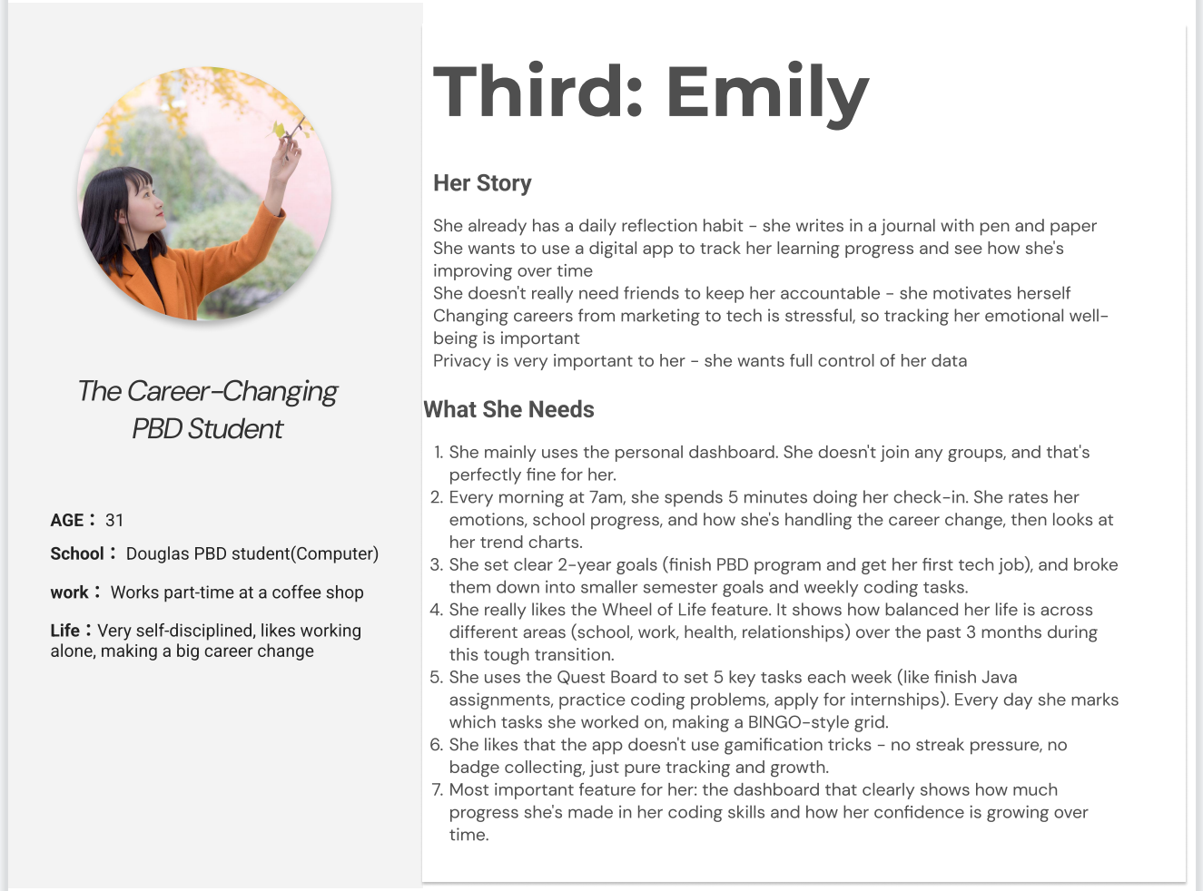

**Persona 3: Emily - The Career-Changing PBD Student**

**Age:** 31 | **Role:** Part-time barista, Douglas PBD Computer Science

**Life:** Very self-disciplined, making big career change

**Her Story:**

Emily has daily reflection habit with pen and paper. She wants digital tracking to see improvement over time. Doesn't need friends for accountability - self-motivated. Career change is stressful, so tracking emotional wellbeing matters. Privacy is very important.

**What She Needs:**

* Personal dashboard - no group requirement
* Morning routine at 7am with 5-minute check-in
* 2-year goals broken into semester goals and weekly tasks
* Wheel of Life showing balance across life areas
* Quest Board for 5 weekly tasks (BINGO style)
* No gamification pressure - just tracking and growth
* Dashboard showing skill improvement over time

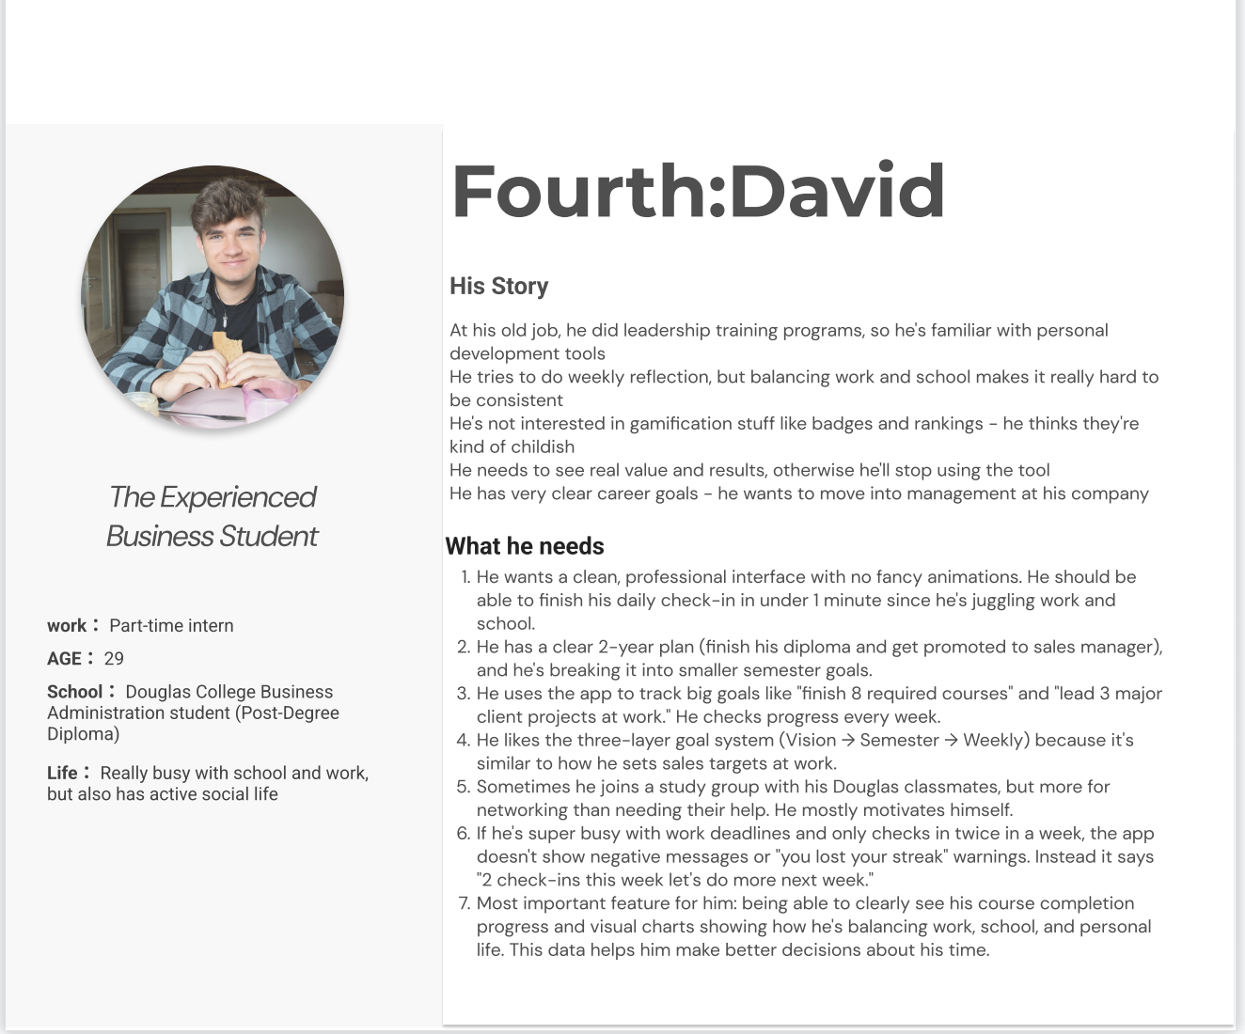

**Persona 4: David - The Experienced Business Student**

**Age:** 29 | **Role:** Part-time intern, Douglas Business PDD

**Life:** Busy with work and school, active social life

**His Story:**

David did leadership training at his old job, so he's familiar with personal development. Weekly reflection is hard while balancing work and school. Not interested in childish gamification - needs real value and results. Has clear career goals for management.

**What He Needs:**

* Clean professional interface, <1 minute check-in
* Clear 2-year plan with semester goals
* Three-layer goals: Vision → Semester → Weekly
* Track concrete goals like courses and projects
* Optional groups for networking, not required
* No negative streak messages during busy periods
* Visual charts for work/school/life balance

### 4.2 Requirements from Personas

Based on analyzing these personas, we generated the following requirements:

**From Sarah (Busy Graduate):**

* Check-in must complete in <2 minutes
* Gentle, customizable reminder notifications
* Visual connection between daily work and long-term goals
* Charts showing emotions/school/relationships over time
* Positive, supportive messaging (never guilt-inducing)
* Daily reflection prompts, not blank pages
* Weekly reset feature (fresh start every Monday)

**From Michael (Team Player):**

* Create small cohorts (5-10 people)
* Show aggregated team progress only
* Emoji reactions for encouragement
* Protected individual privacy
* Team milestones without individual rankings
* Optional win sharing, private by default

**From Emily (Career-Changer):**

* Full functionality in solo mode
* Support for daily morning routines
* 2-year vision with semester and weekly breakdown
* Wheel of Life showing life balance
* Quest Board (BINGO grid) for weekly tasks
* No gamification pressure
* Dashboard showing skill/confidence growth

**From David (Experienced):**

* Clean, professional interface
* Three-layer goal hierarchy
* Track concrete milestones
* Weekly progress checks
* Optional, not mandatory groups
* Supportive messaging during busy periods
* Work/school/life balance charts

## 5. Synthesis of Requirements

### 5.1 Final Prioritized Requirements

Combining insights from user research (14 survey responses) and persona analysis, we created this prioritized feature list using P0-P4 tiers based on user value, strategic fit, and technical feasibility.

**P0 - Must Have (MVP Core)**

**1. Daily Check-In System (<2 minutes)**

* 3 rating sliders: Emotional, Relational, Academic
* Quest selection checkboxes
* Optional quick note (<100 chars)
* **Validation:** 79% want <2min (strongest finding)

**2. Three-Layer Goal Framework**

* Vision (2-3 years) → Quarterly → Weekly
* Shows how daily work connects to long-term goals
* **Validation:** 79% high interest (highest score 4.1)

**3. Progress Dashboard with Visual Graphs**

* Emotion/academic/relationship trends
* Goal completion rates
* Wheel of Life visualization
* **Validation:** 71% prefer visual, 64% high interest

**4. Cohort Space (Aggregated)**

* Small cohorts (5-10 members)
* Shows team averages, not individual data
* Team milestone celebrations
* **Validation:** 64% value peers, 71% need privacy control

**P1 - High Priority**

**5. Push Notifications/Reminders**

* Customizable times, gentle tone
* **Validation:** 64% forget to reflect (top barrier)

**6. Quest Board (BINGO Grid)**

* 5 weekly tasks linked to quarterly goals
* Visual progress without gamification

**7. Encouragement Reactions**

* Emoji support system (💪❤️🔥👏)
* **Validation:** 64% high interest

**8. Structured Reflection Prompts**

* Daily questions guide reflection
* **Validation:** 79% want structure, 29% don't know what to reflect on

**P2 - Medium Priority**

* **9. Milestone Celebrations:** Recognize achievements (validation: 50% want)
* **10. Weekly Planning:** 5-10min weekly intention setting
* **11. Wheel of Life:** Life balance across domains

**P3 - Nice to Have**

* **12. Extended Journal:** Longer reflection option (validation: 50% interested)
* **13. Affect-Agency Grid:** Emotion vs. control mapping

**P4 - Future Phase**

* **14. SEL Timeline:** Social-emotional learning analytics

**Cross-Functional Requirements:**

* **Privacy:** Granular sharing controls, no public rankings
* **Tone:** Always supportive, never guilt-inducing
* **Design:** Function > form, clean professional interface
* **Independence:** Solo mode fully functional

### 5.2 Conclusions

* **Speed is Essential:** 79% want <2min → any longer design will fail
* **Visual Feedback Required:** 71% prefer visual, 0% text-only → dashboard is critical
* **Long-Term Goals Matter Most:** 79% interest → differentiates us from simple trackers
* **Reminders Not Optional:** 64% forget → must add notifications to P1
* **Privacy Enables Social:** 64% want peers BUT 71% need control → aggregated design correct
* **Anti-Gamification Confirmed:** Mature users (65% age 27+) want meaningful progress, not badges

**Surprise Findings:**

* Long-term goals scored higher than daily check-in (79% vs 57%)
* Encouragement reactions (64%) more desired than expected
* Zero users want blank-page journaling

## **6.**Design

注意：这里必须使用最终版的 Figma 截图，不能用旧图

Design Patterns: 使用了哪些设计模式（如导航栏、卡片式设计等）？

Rationale: 为什么选择这些设计模式？

Overall Workflow: 这里的 Figma 全局视图（Bird's eye view of the flow）。

Screenshots: 所有主要界面的高清截图。

## User Study 2 (Prototype Evaluation)

### 7.1 User Journey Map

We developed five comprehensive user journey maps covering the core scenarios of QuestLabs Companion:

1. **Daily Check-in Journey** – Quick emotional and academic tracking (<2 minutes)

**2. Progress Review Journey** – Visualizing personal growth over time

**3. Goal Management Journey** – Connecting daily actions to long-term vision

**4. Cohort Interaction Journey** – Privacy-preserving peer support

**5. Onboarding Journey** – First-time user experience and setup

### 7.2 Objectives

The primary objective of this usability testing was to **validate the effectiveness and usability of our high-fidelity Figma prototype** before final delivery. Specifically, we aimed to:

**Assess Usability:** Measure overall system usability using the standardized System Usability Scale (SUS).

**Validate Core Features:** Confirm that all four core features (Daily Check-in, Progress Dashboard, Goal Framework, Cohort Space) meet user needs.

**Test Task Completion:** Evaluate whether users can successfully complete key workflows without assistance.

**Verify Privacy Design:** Validate our privacy-first approach to cohort features.

**Identify Issues:** Discover usability problems and pain points that need addressing.

**Measure Adoption Intent:** Gauge user willingness to download and use the app.

This testing was critical because it provided real user feedback on our design decisions, allowing us to validate our earlier research findings (14-person survey) and identify areas for improvement before final submission.

### 6.3 Methodology

#### Testing Approach

**Method:** Remote Moderated Usability Testing

**Tool:** Figma Interactive Prototype

**Duration:** 20-25 minutes per participant

**Testing Period:** November 25-27, 2025

#### Participants

Sample Size: 5 participants

Recruitment Criteria:

College students aged 18-31+

Currently enrolled in or interested in personal development programs

High comfort level with mobile applications

Willing to provide honest feedback

**Demographics:**

**Age distribution:** 20% (18-20), 40% (27-30), 40% (31+)

**Tech proficiency:** 100% rated "Very comfortable with mobile apps"

**Gender:** Mixed (not collected to maintain privacy)

#### Testing Procedure

**Phase 1: Introduction (2-3 minutes)**

Explain testing purpose and think-aloud protocol.

Clarify that we're testing the prototype, not the participant.

Obtain consent and answer questions.

Phase 2: Task Completion (15-18 minutes)

Participants completed 4 core tasks:

**Task 1: Complete Daily Check-in** (Rate mood, relationships, academics; Select completed activities; Submit reflection)

**Task 2: Review Progress Over Time** (Navigate to Stats section; View 30-day trends; Interpret Wheel of Life visualization)

**Task 3: Set Up a New Goal** (Explore three-tier goal structure; Create a new weekly quest; Link to higher-level goals)

**Task 4: Interact with Cohort** (View team progress; Explore privacy settings; Find interaction options)

**Phase 3: Post-Test Survey (5-7 minutes)**

Demographics (2 questions)

Task-specific questions (4 questions)

System Usability Scale (10 questions)

Feature importance ratings (4 questions)

Design and visual appeal (2 questions)

Adoption intent (2 questions)

Open feedback (3 questions)

**Total Questions:** 27

### 6.4 Data Visualization & Analysis

#### System Usability Scale (SUS) Results

**Overall SUS Score:** 78.0 / 100 (Grade B - "Good")

*Interpretation:* A score of 78.0 places our prototype in the **75th percentile** (top 25%). It is well above the industry average of 68, demonstrating a strong user experience acceptable for production.

**Individual Participant Scores:**

| **Participant** | **Age Group** | **Score** |
| --- | --- | --- |
| P1 | 18-20 | 65.0 |
| P2 | 31+ | 92.5 |
| P3 | 31+ | 85.0 |
| P4 | 27-30 | 82.5 |
| P5 | 27-30 | 65.0 |
| **Average** | **-** | **78.0** |

#### Task Completion Results

**Key Finding:** 100% task completion across all scenarios demonstrates strong usability and intuitive design.

| **Task** | **Success Rate** | **Avg Ease (1-5)** | **Key Metric** |
| --- | --- | --- | --- |
| **Task 1: Daily Check-in** | 100% | 4.4 | 60% rated "Very Easy" |
| **Task 2: Progress Review** | 100% | 4.6 | 80% found section immediately |
| **Task 3: Goal Management** | 100% | 4.6 | 80% understood 3-tier structure |
| **Task 4: Cohort Interaction** | 100% | 5.0 | 100% felt privacy-comfortable |

#### Feature Importance Ratings (Scale 1-5)

**Key Finding:** All core features rated 4.6/5 or higher, validating our feature prioritization decisions.

**Daily Check-in:** 4.8 / 5 (80% rated 5)

**Progress Dashboard:** 4.8 / 5 (80% rated 5)

**Goal Framework:** 4.6 / 5 (80% rated 5)

**Cohort Space:** 4.6 / 5 (60% rated 5)

**Average:** 4.7 / 5

#### Privacy Validation

**Privacy Comfort:** 100% rated "Yes, very comfortable" (5/5).

**Very Comfortable:** 100%

**Somewhat Uncomfortable:** 0%

**Key Quote:** "I really like the 'Aggregated Cohort' view. It feels supportive to see my group's collective progress without the pressure of sharing private reflections or competing on a leaderboard."

#### Adoption Intent (Download Likelihood)

Average Score: 3.6 / 5

Positive Intent (4-5): 60%

| **Response** | **Percentage** |
| --- | --- |
| Definitely Would (5) | 20% |
| Probably Would (4) | 40% |
| Might or Might Not (3) | 40% |
| Probably Not (2) | 0% |
| Definitely Not (1) | 0% |

#### SUS Statement Breakdown

**Strongest Areas (5 = Best):**

**Consistency:** 5.0/5 ("Very little inconsistency")

**Independence:** 4.8/5 ("Don't need technical help")

**Ease of Use:** 4.8/5 ("Easy to use")

**Learning Curve:** 4.4/5 ("Students would learn quickly")

**Areas for Improvement:**

**Complexity:** 2.0/5 (Some users felt slight complexity)

**Learning Required:** 2.4/5 (Some initial learning needed)

### 6.5 Insights (Findings)

Based on comprehensive analysis of usability testing data, we identified the following key findings:

#### ✅ Validated Strengths

**Core Functionality Works Well:** 100% task completion rate across all 4 testing scenarios with an average ease rating of 4.6/5. No participants struggled to complete tasks.

**Privacy-First Design is Successful:** 100% of users felt comfortable with cohort privacy features, specifically praising the "aggregated view" approach.

**Three-Tier Goal Framework Resonates:** 80% immediately understood the *Vision → Quarterly → Weekly* structure. Users cited this as a high-value feature for connecting daily actions to long-term goals.

**Visual Progress Dashboard is Effective:** 100% found charts and graphs clear. The Trend lines and "Wheel of Life" were the most valued visualizations.

**Design is Consistent and Learnable:** Scored 5.0/5 on consistency and 4.4/5 on learnability.

#### ⚠️ Critical Issues Identified

**Issue 1: Lack of Cohort Interaction Features** (Mentioned by 60% of users)

**User Feedback:** "Sometimes I want to send a short 'Keep it up' text message to the group, but I can't." / "There should be a Notify section to add interaction."

**Impact:** High. This is the #1 most mentioned frustration.

**Severity:** Critical (Affects core value proposition of peer support).

**Issue 2: Habit Formation and Reminder Challenges** (Mentioned by 20%, implied by others)

**User Feedback:** "I'm a lazy casual guy. It's highly likely I'll forget to check in..."

**Impact:** High. Directly affects daily engagement.

**Severity:** Critical (App depends on daily habit formation).

**Issue 3: Non-Clickable UI Elements** (Mentioned by 20%)

**User Feedback:** "Some icons cannot be clicked."

**Impact:** Medium. Breaks user expectations.

**Severity:** High (Creates confusion).

**Issue 4: Wheel of Life Color Contrast** (Mentioned by 20%)

**User Feedback:** "The color of the wheel of life... is not very contractive and hard to be distinguished."

**Impact:** Medium. Affects visualization clarity.

**Severity:** Medium (Accessibility issue).

#### 🔍 Secondary Issues and Improvement Opportunities

**Differentiation Concerns:** Users asked how to distinguish this from similar apps (Marketing/Positioning challenge).

**Desire for Passive Tracking:** Some users requested screen-time tracking without opening the app (Future enhancement).

**Need for Templates:** Users requested practical examples for goal setting (Onboarding enhancement).

#### 📊 Validation of Original Research

Our testing validated all major findings from our initial 14-person survey:

| **Original Finding (Survey n=14)** | **Testing Result (n=5)** | **Status** |
| --- | --- | --- |
| 79% want <2min check-in | Avg ease: 4.4/5 | **Validated** |
| 71% prefer visual tracking | 100% found charts clear | **Validated** |
| 64% value peer accountability | 100% motivated by cohort | **Validated** |
| 71% need privacy control | 100% felt comfortable | **Validated** |
| 64% "forget to track" pain | Users mentioned forgetting | **Validated** |

#### 💡 Key Insights Summary

**What's Working:**

Core usability is strong (SUS: 78.0).

Privacy-first approach is a clear differentiator.

Goal framework provides a unique value proposition.

Visual design is clear and consistent.

**What Needs Attention:**

**Critical:** Add cohort interaction/notification features (60% request).

**Critical:** Implement habit formation reminders (retention risk).

**High:** Fix non-clickable UI elements (trust issue).

**Medium:** Improve Wheel of Life color contrast (accessibility).

Strategic Recommendation:

The prototype demonstrates strong product-market fit with above-average usability. The most critical gap is the lack of notification/interaction features in the cohort space. Addressing this while maintaining privacy-first design would significantly strengthen the product.

### 6.6 Changes to Design

**[TO BE COMPLETED AFTER TEAM DISCUSSION]**

Based on the findings above, we need to discuss and decide:

Which issues will we address in the current iteration?

Which improvements are feasible within our timeline?

Which valuable features should be documented as "Future Work"?

#### Implemented Changes

*(Insert finalized changes here)*

#### Future Work (Deferred Due to Time/Technical Constraints)

*(Insert deferred features here)*

这是 Final Report 与中期报告最大的区别，也是评分重点

User Journey Map: 绘制用户旅程图（展示用户在 App 中的触点）。

Objectives: 为什么要做这次测试？（目的是验证原型好不好用）。

Methodology: 测试方法（如 Usability Testing）、样本人群。

Data Visualization & Analysis: 测试结果的数据图表。

Insights (Findings): 用户反馈了什么问题？

Changes to Design (关键得分点):

列表说明：基于用户反馈，你们修改了原型的哪些地方？

列表说明：哪些反馈很有道理，但因为时间/技术限制，这次来不及改（Future Work）？

## **8.**Conclusion

简短总结项目的成果和学到的经验。

## **9.**AI Use Section

Value Addition: 说明你们在 AI 生成内容的基础上，人工增加了什么价值（证明不是完全依赖 AI）。

## **10.**Appendix

User Study 1 Materials: 问卷/访谈草稿。

User Study 2 Materials: 评估测试的问卷/脚本。

AI Prompt History: 所有的 AI 提问历史记录（复制粘贴即可）。

## 11. References

引用格式规范。

## Work Logs

提交前最后检查 (Final Checklist)

[ ] Team Lead 在 Blackboard 上传 PDF。

[ ] Team Lead 将 PDF 上传到 GitHub (DocumentsAndReports 文件夹)。

[ ] 检查 README.md 是否包含项目介绍和“如何运行/查看 Demo”的说明。

[ ] 准备 5分钟演示 (Demo) 的讲稿或 PPT（虽然报告不用交 PPT，但明天可能要讲）。